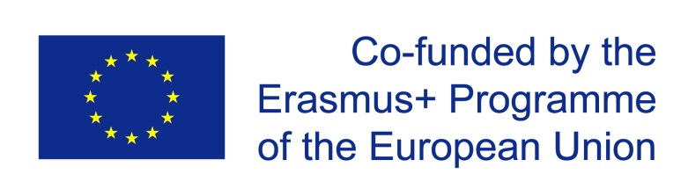
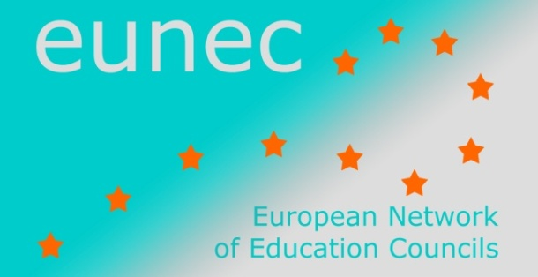

Main Policy Lines in Education and Training

(May 2014 – October 2014)

- OECD

1 Results of TALIS 2013
25 June 2014
The OECD Teaching and Learning International Survey (TALIS), first launched in 2008, asks teachers and schools (ISCED level 2) about their working conditions and the learning environments. It covers important themes such as initial teacher education and professional development; what sort of appraisal and feedback teachers get; the school climate; school leadership; and teachers’ instructional beliefs and pedagogical practices.
TALIS provides cross-country analysis that helps countries identify others facing similar challenges and learn about their policies.
The results of the 2013 edition show that more than nine out of ten teachers are satisfied with their jobs and nearly eight in ten would choose the teaching profession again. But fewer than one in three teachers believe teaching is a valued profession in society. Importantly, those countries where teachers feel valued tend to perform better in PISA.
www.oecd.org/TALIS

Education at a glance 2014
9 September 2014
Education at a Glance 2014 is the annual report by the OECD on the state of play and challenges faced by national education systems. It highlights the growing importance of investment in education for future growth and employment in the EU and for more inclusive European societies.
Education at a Glance draws on data compiled by the OECD and UNESCO. The 2014 publication also draws from the results of recent OECD surveys: PIAAC, PISA, and TALIS.
Main findings about the EU in Education at a Glance 2014:
- Educational opportunities continue to expand significantly in Europe. The share of the adult population with tertiary education has steadily increased in most EU countries during the past decade (to 29%), the share of pupils with less than upper secondary education has decreased. The report confirms the Commission's analysis that, if current trends continue, the Europe 2020 targets for education and training are within reach.
- High levels of education and skills pay off for both individuals and society.
- Similar levels of educational attainment do not always mean similar levels of skills. There are significant differences in the EU between the skills levels of people with similar qualifications.
- The right skills matter during the transition from education to work. Interpersonal skills such as communication and team work are becoming more important and work experience during studies is a plus for the employability of higher education graduates.
- The teacher population is ageing.
- Private investment in tertiary education is growing. A recent study published by the Commission concludes that student support systems (grants and/or loans) are crucial for offsetting the impact of tuition fees on student enrolments.
Key findings, summary reports at country fiches at http://www.oecd.org/edu/eag.htm.

