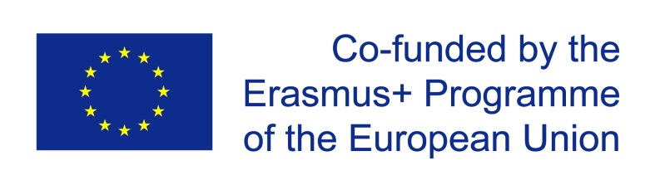
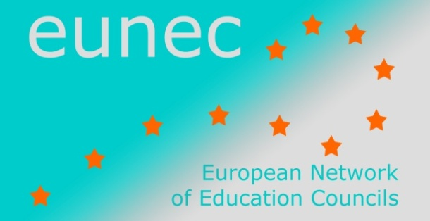

Main Policy Lines in Education and Training

(October 2014 – November 2014)
- UNESCO

Towards indicators for a post-2015 education framework
17 November 2014
The report puts forward a set of global education indicators related to
- The seven post-2015 education targets proposed by the Education for All steering committee in May 2014;
- The ten education targets proposed by the Open Working Group of the United Nations General Assembly in July 2014.
In proposing indicators, two key criteria were identified:
- Alignment: To what extent does the indicator measure accurately and fully all the concepts that are included in the target?
- Global comparability: Does the concept have the same meaning in all places? Can it be measured in the same way in all places? Are the data collected in the same way globally, in a sufficiently large number of countries, and on a regular basis?
Targets are related to
- Early childhood
- Primary and secondary education
- Skills
- Equity
- Literacy
- Global citizenship
- Schools
- Scholarships
- Teachers
- Finance
This document is subject of a public consultation running from 17 November 2014 until 30 January 2015. Comments to the TAG proposal must be submitted using the feedback form and sent via email to uis.publications@unesco.org with ‘Education Indicators Post-2015’ as a subject heading.
The report

