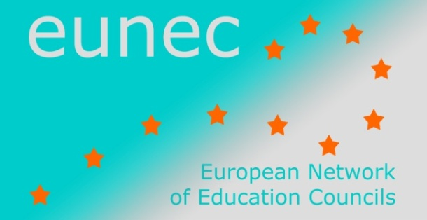 | 22 May 2013
 | EUN/EC/DOC/003

Main Policy Lines in Education and Training

December 2012 - May 2013
OECD

Mental health and work
OECD, 2012
Mental health is becoming a key issue for the well-functioning of OECD’s labour markets and social policies. There is only very little awareness about the connection between mental health and work, and the drivers behind the labour market outcomes and the level of inactivity of people with mental ill-health. Understanding those drivers is critical for the development of more effective policies. This book aims to identify the knowledge gaps and try to narrow them by reviewing evidence on the main challenges and barriers to better integrating people with mental illness in the world of work.
An important chapter of the book is dedicated to ‘Education systems and the Transition to Employment’.
Read more on the OECD mental health and work project.

The OECD Survey of Adult Skills
The OECD Survey of Adult Skills is an international survey conducted in 33 countries, as part of the Programme for the International Assessment of Adult Competencies (PIAAC). It measures the key cognitive and workplace skills needed for individuals to participate in society and for economies to prosper. It is the largest and most comprehensive international survey of adult skills ever undertaken.
The results are expected in October 2013.
Read more about implementation, design and beneficiaries of the study.

Trends shaping education
The first edition of this book was published in 2008, the second in 2010. It provides an overview of key economic, social, demographic and technological trends and raises pertinent questions about their potential impact on education. It makes use of a variety of robust international data resources (including OECD, World Bank and United Nations).
The material is organised in five main chapters
- Globalisation
- Well-being and lifestyle
- Skills and labour market
- Modern families
- New technologies

In each chapter a number of trends are illustrated by figures. The criterion for selection of the trends have been the relevance for education and the availability of internationally comparable evidence.
The tool is relevant for everyone in education: policy makers, officials, advisors, researchers, leaders of educational institutions and other stakeholders, teacher educators, teachers.
Read more

Education Policy Outlook
April 2013
The OECD Education Policy Outlook is meant for policy makers, practitioners and analysts, and reviews different education policies and practices that have been initiated across OECD member countries. It focuses on key policy areas such as raising student outcomes, supporting school improvement, and organizing education systems so as to deliver education policy more effectively.
Read the blog by Andreas Schleicher or go to the website of the Education Policy Outlook: http://www.oecd.org/edu/policyoutlook.htm

