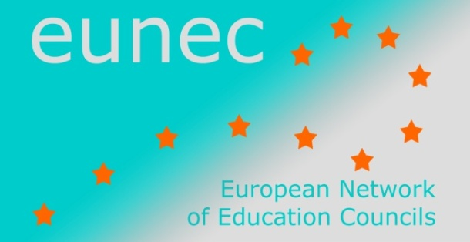

EUN/DOC/026
STATEMENTS on ‘Community Schools’

EUNEC Seminar

Brussels, 23 -24 May 2013

EUNEC
EUNEC is the network of education councils in the European Union. EUNEC brings together the expertise of advisory bodies and of the stakeholders and experts who are involved in the national/regional advisory processes. These advisory bodies give advice to the governments of the different European countries in the field of education and training.
Scope and working method
The central theme for this seminar is the embeddedness of schools in the local society and communities. A community school invests in networking and cooperation with relevant partners in and outside the school in order to broaden the scope of learning, to enlarge the educational time and to raise the quality of the educational offer, with the objective of enhancing the performances of all pupils.

It is a concept linking excellence in education with many other pedagogical and social challenges such as equal opportunities, social cohesion, informal learning opportunities, parental involvement in schools, policy making capacity of schools. In this sense, this seminar is related to former discussions by EUNEC, on ‘Bildung from a lifelong learning perspective’ (Budapest, 2011), on ‘Excellence in education’ (Amsterdam, 2012) and on the educational challenges due to migration (Larnaca, 2012)

In order to enrich the debate, EUNEC members were asked to send a contribution from their country, exploring whether the concept of community schools is known and at which policy level it is integrated, and from which perspective the issue is raised.

STATEMENTS

Community schools are closely associated with new understandings of learning

A new concept of learning
During the last decade consciousness has grown that formal learning processes alone cannot guarantee a high level of competence development in education. Qualitative education starts from an approach based on learning outcomes and processes integrating formal, informal and non-formal learning. As a consequence, the different contexts wherein learning is taking place become part of the educational scope. Contexts can be the peer group and the social network of youngsters, their family and socio-economic environment, their cultural heritage and multiple cultural interests.

In this context, community schools are a very powerful concept to rethink and reshape education as an active actor in a societal environment. The social and cultural environment is connected to the school life and educational processes and valorized to enrich the learning processes of the pupil. Community schools are not based on a unilateral demand from education to other sectors. They are built on getting connected, on strong partnerships and tangible win wins aiming at strengthening the learning of pupils, the school as an organization and the community building capacities in society. The (educational) perspective of community schools reaches far beyond remediation of pupils at risk or extra-curricular activities.

Although all community schools are the result of broadening the working field and horizon of the school, the concrete scope can be diverse: build overarching strategies tackling disadvantage, overcome special needs, improving the competence and motivation level of students by linking with cultural field, in sports, smoothening the bridge between learning and working, tackling early school leaving, enhancing the livability of major cities with problematic social cohesion, …

A whole range of benefits can be demonstrated. Community schools’ pupils show significant and widely evident gains in academic achievement as well as in areas of non-academic development. Families of community school pupils are more involved with schools and show increased stability. They demonstrate a greater sense of responsibility for their children’s learning success. Community schools show increased teacher satisfaction and a more positive school environment. They promote better use of school buildings, and the neighborhood enjoys increased security and heightened community pride.

Interrelation between education and other provisions
Often, we witness a compartmentalization of different services and actors: child care, school, welfare, police, preschool services, library, transport, housing providers, health services, local authorities, non-profit organizations, parents’ organizations, …
When all these actors are brought together, this offers a different angle of looking at the relation between education and society: schools are seen as social capital in the community, and the community is appealed to have a say in education, with the needs and deficiencies, the chances and opportunities of the children and youngsters at center stage.
Therefore EUNEC considers community schools as an important instrument in the global European approach to open up education to the broader world.

A clever change strategy

Clarifying the goals fit for the context
A community school is, given its definition and scope, closely linked to the context and the social and cultural environment of its setting. Therefore, it is not feasible nor desirable to define community schools from one single viewpoint.
The scope of a community school depends on the level of centralization or autonomy of the macro educational system. It depends on the local conditions such as the tension between rural areas with and big cities. It depends on the composition of the school population and its social and cultural features.
Therefore each school or region should start from a white canvas and set forward its own purposes based on its mission and an evidence based analysis of the context. Depending on the goals set forward a school can search partners, utilize their experience and knowledge, and intensify the exchanges.
Different models and scopes are possible.
Models.
Services can work together in different settings, in a network. Services can work together in multifunctional accommodation, in the same building, but still working separately. Finally, all services can work together in an integrated way: one organization, one vision, one team that cooperates with the surrounding area.
A community school has to reflect on its focus and on its scope.
The focus can go from tackling disadvantage to enriching lives. The scope can go from an individual approach from the children’s learning in school to a social and community renewal.
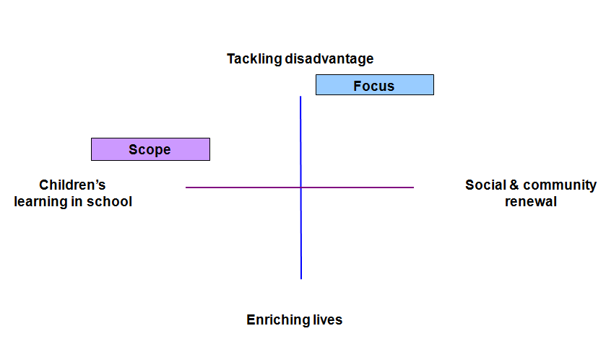
Schools and their partners have to consider how different strands of learning can be linked: early childhood, elementary and secondary programmes and programmes for lifelong learning.
Every community school has to be aware of its position within these different approaches. Reflecting on this position will lead to clear purposes, to a clear focus and allow a long term evaluation.

A sustainable innovation strategy
Community schools are often initiated by enthusiastic and committed teachers, members of the school team and members of the board of governors. This is, of course, a very good way to initiate a community school. But it is not a good way to make community school effective in the long term. Community schools should be the result of a long term, strategic and sustainable policy set up in schools as well as in the surrounding social, economic and cultural network.
To build effective community schools in the long term, there is need for a clever innovation strategy with clear locally defined purposes.
Schools and administrations have to be aware of what they are trying to achieve. This issue is critical. If purposes are not clearly defined at the school level and shared with the school team and the network of schools, the effect will be the ‘roman candle’ effect, with firework going in different directions without a specific focus.
Schools and community should rely on a theory of change. They start with an analysis of the current situation. Then the actions are defined. The actions come together in two or three broad strands.
The community school explains how each action is expected to impact, step by step. The community school demonstrates how all the actions come together in a strategy leading to long term outcomes. This is far from the roman candle described supra. The theory of change model offers the advantage that schools can demonstrate that they reach what they claim to achieve, which is crucial in terms of evaluation.
The commitment and involvement of the team is crucial: the teachers, and the school leader. The concept of community schools calls for inspiring school leadership, so that all staff members share the same vision and show strong moral commitment: there is a community ethos all over the school.
Next to teachers, it is useful to involve other professionals in the school; in some cases, they might be more trusted than the teachers or the school director. If community schools are driven exclusively by education professionals, there is a risk that they have a narrow view on the world, on the community. The involvement of an independent organization focusing on getting the children’s life better, and not only on their educational achievement, can be a success factor.

Balancing between school autonomy and government facilitating
The autonomy of schools is crucial. Legislation should leave space to a local policy and specific shapes of a community school fit to the challenges of the context. By definition community schools work in a local context.
The government has to set out broad principals and purposes, but implementation has to be local. The government has to support schools in planning and to get in place systems that allow effective networking. It is the local network that is challenged to develop a local response to the central framework. The authorities can assist schools in strategic planning; the technical planning is the responsibility of the local team.
All the community services are involved, but it is recommended not to leave everything to the professionals. A good community school should listen to the voice of all actors, and involve in particular the parents through approachable activities. The resources of local people cannot be underestimated, it is crucial to involve them. There will be need for support, as they are not used to be involved.

A community is a good school with a community ethos
During the discussions, EUNEC members realized that it is not clear which criteria are required to classify a school as a community school. Every school has or should have at least to some extent the characteristics of being involved in the community. All schools organize a number of activities and projects that could be categorized as ‘community related’.
According to EUNEC, the most important difference between just a good school and a community school is the perspective: where the perspective of a good school is educational, the perspective of a community school is broader: the community ethos underpins all working practices, policies and procedures. This broader perspective refreshes school culture; education is enriched by the huge power that is present in the community.
It is reasonable to believe that a community school can be more effective than another school, but it is not reasonable to believe that a community school can solve all the problems in education, in the community, in the society. Community schools are a model trying to tackle problems that go beyond schools. Therefore, a strategy is needed that goes beyond the schools.

EUNEC statements on ‘Bildung from a lifelong learning perspective’ (Budapest, 2011) at http://www.eunec.eu/event/seminar-bildung
EUNEC statements on ‘Excellence in education’ (Amsterdam, 2012) at http://www.eunec.eu/event/seminar-excellence
EUNEC statements on ‘Migration and education’ (Larnaca, 2013) at http://www.eunec.eu/sites/www.eunec.eu/files/attachment/files/statements_0.pdf
Input by EUNEC members at http://www.eunec.eu/eunec-work-news/eunec-seminar-community-schools-brussels-23-24-may-2013
Communication from the European Commission, ‘Rethinking education. Investing in skills for better socio-economic outcomes.’, 20 November 2012. (http://ec.europa.eu/education/news/rethinking/com669_en.pdf)

