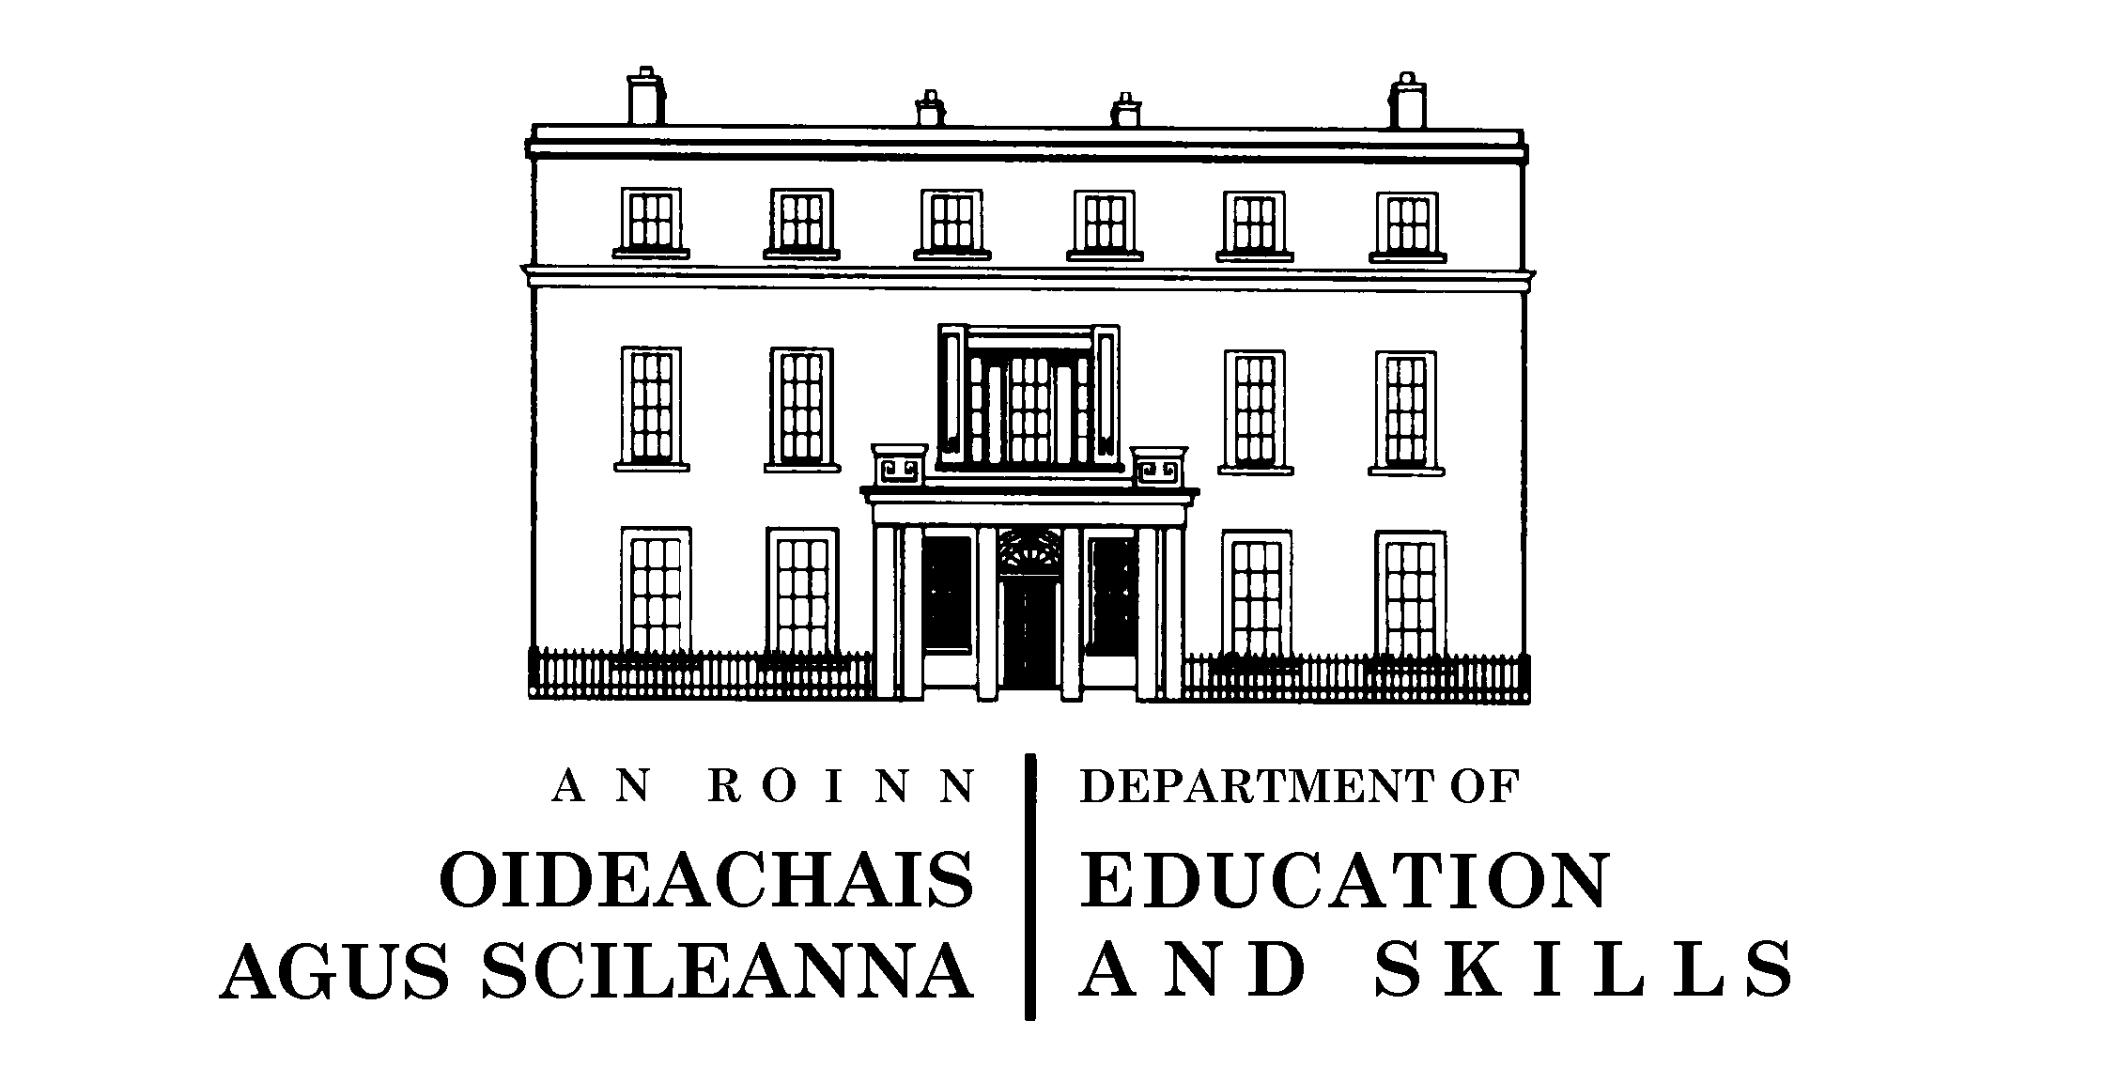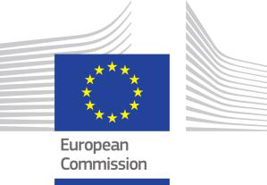

Irish Presidency Conference

Better Assessment and Evaluation to Improve Teaching and Learning
19-20 March 2013

Draft Programme
__________________________________________________________________________

Day 1: Tuesday 19th March

8.45 – 9.15 | Registration and Coffee
9.15 – 9.30 | Opening Address:  Seán Ó Foghlú, Secretary General, Department of Education and Skills
9.30 – 10.00 | Opening Address:  Representative of the European Commission
10.00 – 11.00 | Key Note Address: The Assessment of Key Competences in Schools:  Tapio Säävälä, Head of Sector, European Commission
11.00 – 11.30 | Tea/Coffee
11.30 – 13.00 | Keynote Address: The Assessment of Key Competences: Implications for Practice:  Professor Paul Black, Emeritus Professor of Science Education, King's College, London  The Assessment of Key Competences: A Response from Ireland Professor Eugene Wall, Mary Immaculate College, Limerick
13.00 – 14.00 | Lunch
14.00 – 15.00 | School Evaluation to Support the Acquisition of Key Competences  Professor Graham Donaldson, University of Glasgow
15.00 – 15.30 | Coffee
15.30 – 17.00 | Parallel Workshops: Evaluation and Assessment of Key Competences in Practice  This session will enable delegates to interrogate the specific themes of the conference with a focus on examples of good practice
Day 2: Wednesday 20th March 2013

9.30 – 10.45 | Keynote Address: OECD Review on Evaluation and Assessment Frameworks for Improving School Outcomes  Dr. Paulo Santiago, Senior Analyst, OECD Directorate for Education
10.45 – 11.15 | Coffee
11.15 – 12.15 | Evaluation and Assessment: A Response from Ireland to  The OECD Framework  Dr. Harold Hislop, Chief Inspector, Department of Education and Skills
12.15 – 13.00 | Panel Discussion on Themes of Conference  Facilitator: Dr. Anne Looney, Chief Executive of National Council for Curriculum and Assessment
13.00 – 13.30 | Ministerial Closure of Conference  Ruairí Quinn, T.D., Minister for Education and Skills
13.30 – 14.30 | Lunch

