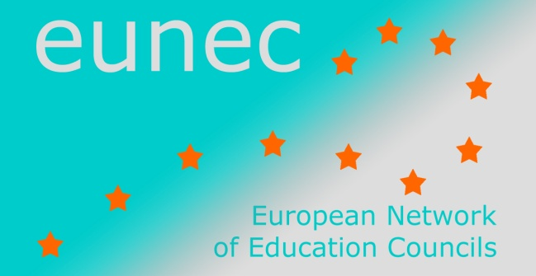

Governance in education

Amsterdam, 30-31 May 2016

LIST OF PARTICIPANTS
Alvaro Almeida dos Santos Portuguese Education Council
Magdalena Balica Institute of Educational Sciences, Romania
Miranda Bik Dutch Education Council

Tracey Burns OECD
Agnė Brandišauskienė Education Council Lithuania
Hein Broekkamp Dutch Education Council
Patricia Chighini CEF (Education and Training Council of the Federation Wallonia-Brussels, Belgium)
Antina de Jong Dutch Education Council
Carine De Smet EUNEC secretariat
Jurriën Doelens Dutch Education Council
Manuel Dony President CEF (Education and Training Council of the Federation Wallonia-Brussels, Belgium)

Mia Douterlungne EUNEC general secretary and general secretary of the Vlor (Flemish Education Council)
Sandra Ebejer Curriculum Management Department, Malta
Ciprian Fartusnic Institute of Educational Sciences, Romania
Roos Herpelinck Vlor (Flemish Education Council)
Edith Hooge TIAS School for Business and Society, Tilburg University
Serban Iosifescu Romanian Agency for Quality Assurance in Pre-university Education
David Justino President CNE (Portuguese Education Council)
Eleni Karnou Cyprus Pedagogical Institute
Elly Loman Hyperion Lyceum
Krista Loogma Estonian Education Forum
Manuel Miguéns Secretary General CNE (Portuguese Education Council)
Tomás Ó Ruairc The Teaching Council Ireland
Yiannis Savvides Cyprus Pedagogical Institute
Tas Szebedy President Public Education Council, Hungary
Vilija Targamadzė President Education Council Lithuania
Adrie van der Rest EUNEC president and secretary director of the Onderwijsraad (Dutch Education Council)
Jiri Zajicek President Union of Schools’ Associations, Czech Republic

