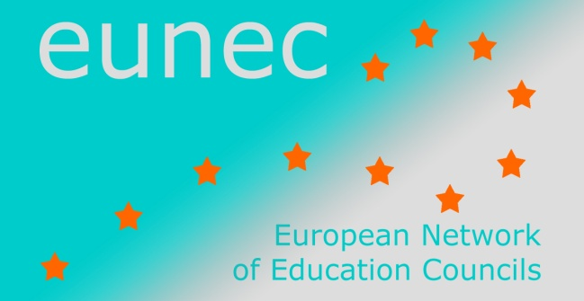

Seminar on ‘Community schools’

Brussels, 23-24 May 2013

INPUT FROM EUNEC MEMBERS

Union of Schools Associations Czech Republic
Is this theme part of the policy debate in your country?
Yes, it is, but we can see that it is more important and more actual in the regions, districts or parts of bigger towns where there are not so much social problems, with lower rate of unemployment, where people are not poor and don´t have the basic existential concerns. In the region with social problems it sometimes seems as an “irrelevant luxury” for the people with the basic existential problems. It is clear that the main task of the school that wants to be the centre of local community is to persuade people, both parents and pupils (students) that it can be fine and very useful for them to join the activities of THE COMMUNITY SCHOOL They can find there very good relevant support for their needs which costs very little money or nothing. It is very important to attract people, institutions and small entrepreneurs and craftsmen to cooperate with the community school. It will also help them in the future.
Is the definition set forward by EUNEC relevant?
Yes, it is relevant from the perspective of lifelong education needs.
Are essential elements missing?
We think that it is alright.
Do you recognise the difference between community schools and multifunctional schools?
At first we think and understand the community school is less formal than multifunctional school. The activities there can be wider or vice versa very narrow. It depends on opportunities of all schools. Community school can consist of more parts – like a library, theatre, afters schooling activities etc.
What is the perspective from which the issue is raised?
The debate on equal opportunities is number one, because a lot of talented pupils and students leave schools early without any education. The background of the problem is the low support to pupils who are not encouraged by parents and familyraising levels and standards of learning – as a part of next steps.
Integration of formal and informal learning is at the very beginning in our country. Mostly informal education isn´t well developed, and isn´t formally accepted.
Do you have any relevant recommendations on this theme?
The headmaster of the school must be absolutely persuaded that the cooperation with the local community is necessary; the school is able to offer much more than traditional education – many after schooling activities for pupils and their parents, grandparents and for their younger brothers and sisters as well. The school is a multigenerational institution. And education is a lifelong process. All members can use all strong points of them and have to know about their weakness, they want to find all opportunity and dangers of the environment. There must be strong and wide support of local political and educational authorities. Start from smaller goals. Get ready to accept the first failures and jeers. Remember:
- The most important is always cultivation of pupils. There are both levels IQ and EQ . (knowledge and social skills together)
- Connect education and activities inside of the community
- All communities´ activity must be part of the school’s concept
- Embodied energy and efforts must be reasonable
- Feedback and annual evaluation are not only good, they are necessary. Use wider forms of it. Ask the bystanders as well. Use all examples of good practice.
- Try to inform about the life at community school as more as possible. Celebrate a lot.
- Ask people inside the community what they like, what they need what is good for them.
- Take advantage of locally embedded learning – for example projects which are connected with the area- history, nature, locally famous people
- Encourage all type of local positive partnership.
School level: Is the concept of “community schools” known in your country?
Yes, it is. There are schools which work as a community school, but we can´t say that there is one model or one shape of the community school. There are differences between schools in bigger towns and villages, in the western part of Bohemia and south Moravia.
Or is it used with another name?
Yes, some of them are for example named – Healthy school or green school. Lesní školky jako komunitní zařízení.
Are there schools in your country working with this concept?
Yes some of them respect the so-called “Ten Commandments”
WHAT THEY WANT
1.They want to change schools
2.They want to get rid of wrong views
3.They want more than just part knowledge
4.They want to build on the natural human needs
5. They develop individual assumptions and take into account the particularities of each individual
WHAT THEY OFFER
6.Greater degree of freedom for pupils
7.Greater freedom in deciding
8.Good psychological climate, good relationships and tolerance
9. They support all kinds of creativity, cooperation and openness
10. They are ecological, healthy, esthetical, open, economy and friendly schools.

What are their experiences of difficulties?
They often meet with scepticism. Parents are afraid that students can only play and don´t learn the important things for their next life.
Central policy making level: Is the concept integrated at a central policy level?
There are some efforts on the government level but the results are mostly not too big and too good. Sometimes there are some proposals on the level of ministry of education which allows also to community schools to get some extra money for their projects and actions.
What is the role of the central government, of the community and of the school?
They should create a legislative framework and help them get money or other support. To help them integrate them to the official structure of state aid.

By Miloslav Hons, Headmaster of Basic school Chomutov, Na Příkopech 895

