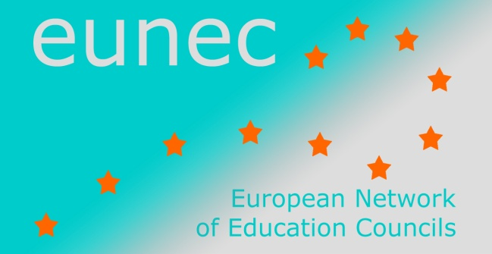

Seminar on ‘Community schools’

Brussels, 23-24 May 2013

INPUT FROM EUNEC MEMBERS

Education Council Portugal (CNE)

Improving the relations between schools, local community and networking platforms
This is not a relevant topic in our present political agenda. Schools are free to develop projects and activities involving local communities, municipalities, local associations or enterprises.
We would suggest that EUNEC definition could be wider, since when involving other partners, schools should not only aim at improving learning outcomes but also promoting the social development of the community they serve.
The debate on this issue should consider
- equity, equal opportunities for students from different social and cultural origins;
- integration of different learning contexts – formal, informal and non formal;
- better results – students with better learning performances.
School can be better if the cultural level of the local community as whole is higher.
The National Council of Education (CNE) addressed the theme of school – community partnerships in several published statements arguing that organizations with an educational potential (formal, non-formal, informal) within a particular school community should establish partnerships and promote networking activities in order to devise education and training offers to respond to local needs. Thus, schools, training centres, firms, municipalities, associations, museums or science centres for example, that operate at a particular territory school collaborate to involve locals, youngsters and adults, in lifelong learning activities.

The concept of community schools
The connection between schools and communities has been implicit in public policies concerning decentralization and school autonomy implemented since 1975.
Despite the fact that the concept of “community schools” is not a current concern in Portugal, there are some institutions with practices that could be associated to such an approach.
The expression “integrated territorial approaches” is commonly used to refer to educational projects that associate formal and non-formal and promote learning experiences using the local as the reference or the starting point. Such projects tend to establish partnerships with different local actors, mainly municipalities.
Nowadays the Ministry of Education runs different programs involving several community partners in order to improve school performances. These programs are usually implemented in economic and socially deprived areas with severe problems of poverty, violence and school failure. In these contexts schools are integrated in TEIP – Educational Territory of Priority Intervention. Starting in 1996, this approach involves about 9% of the schools.
Other projects involving mainly rural and isolated schools were developed during the 90s trying to promote social and cultural development of the community by using the school as the reference or the starting point. With a perspective of integrated development, these projects tried to promote culture, education, health and environment within the local community, using the school as a development pole.
However, school merging policies and migration to urban centres would result in the extinction of those isolated and rural schools.

