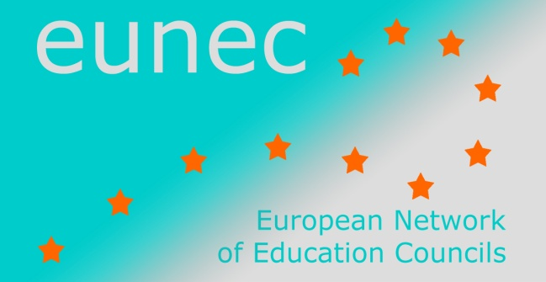

Seminar on ‘Community schools’

Brussels, 23-24 May 2013

INPUT FROM EUNEC MEMBERS

Flemish Education Council
The development of community schools in Flanders and Brussels is relatively new. Of course there existed schools that collaborated with other partners, that widened their scope, that wanted to support the integral development of children and youngsters. But at the policy level, interest in the concept developed in 2004. Community schools are a typical ‘bottom-up’ process that cannot be forced by regulations. But, at the same time the government can facilitate the development by eliminating judicial obstacles, making it easier to combine different financial sources etc. From 2006 until 2009 the Flemish minister of Education granted subsidies for 17 pilot projects. In the final report recommendations about the implementation of community schools in Flanders and Brussels were written. The pilot projects showed that the local authorities play an important role in what the focus of community schools is, as they focus on the immediate needs of children and youngsters in a specific environment. Further research by the Centre for Diversity and Learning (Ghent University) shows that municipalities work on different tracks to support community schools. In four bigger municipalities, community schools are supported by the municipality, not only in funding, but also by giving training, providing a coordinator etc. Not every municipality has a common framework supported by the council. If this is the case, more cooperation between different services at the municipality level is possible and different schools are included in the network of community schools.
The idea of a city starting up a community school arises mostly in underprivileged areas. Community schools are seen as a way to tackle inequalities in society. However, community schools do not want to stigmatize underprivileged groups or keep them in their deprived situation. It is exactly the mix and exchange of experiences, visions and ideas that create enrichment. That is why a broad target group is deliberately aimed at, that is all children en youngsters. Community schools therefore also widen the outlook of children and youngsters from well-to-do and sheltered environments. Everyone contributes to a rich exchange and helps to build bridges and close gaps.
The text boxes below contain a summary of the Community schools starting points and touchstones. They make out the Community school reference framework.
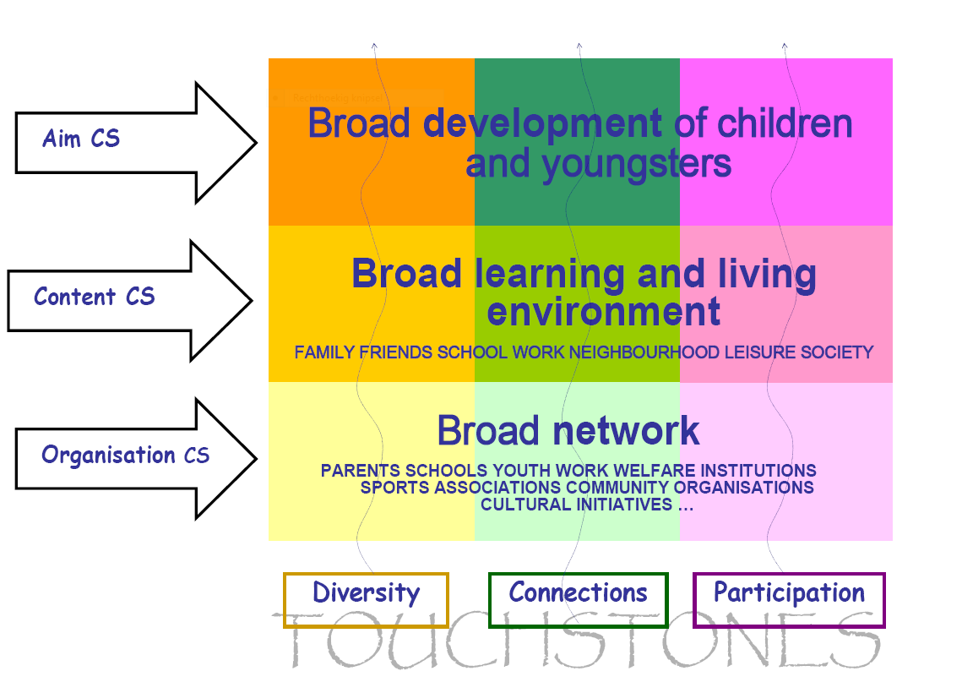
The aim of the community schools: broad development of children and youngsters. For children and youngsters not to be in the margin of society, they have to develop an enormous amount of competencies. A Community school stimulates and promotes these competencies. The total development of the personality occupies centre stage. Diversity is a key element in that respect: a variety of manners, talents, learning styles, interests and needs. The variety of the public is important as well. Community schools want to participate in the realisation of a broad development for all children and youngsters. However, this does not exclude attention being paid to equal opportunities.
The content: a broad learning and living environment. Children and youngsters mover through a multitude of learning and living domains, and learn within formal as well as informal contexts: school, sports associations, cultural initiatives, youth work, neighbourhood, peer group, family.. Community schools stimulate and link the experiences and competencies they acquire everywhere, by increasing interaction between these different domains.
The organisation: getting to network. In a Community school, partners equally collaborate with a common goal in a broad network. Partners actively look for possible connections and opportunities, common goals, shared concerns and joint actions. A Community school cannot but take shape at the local level. This movement can also be instigated top down. Municipalities and/or organisations that are active at supralocal or meso level can play an inspiring and stimulating role.
The Flemish Education Council has no recommendations on this subject. The Council organized a seminar on the theme of ‘Community schools’ in December 2011. A report and presentations can be found (in Dutch) at http://www.vlor.be/verslag/seminarie-de-brede-school.

Based on the vision text ‘Community Schools in Flanders and Brussels. A framework for development’, under the authority of the Minister for Work, Education and Training of the Flemish Government, 2006.

