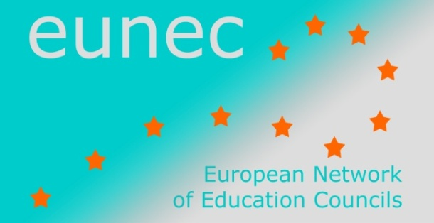

Questionnaire on the positions of education councils regarding the Corona Crisis
Superior Council of Education, training and research
MOROCCO

- Policy issues
Describe the main policy issues regarding the COVID 19 education policy
Which were the main measures adopted during the lockdown (particularly those measures related to teaching and learning), Specify if relevant the education level concerned e.g. primary, vocational, higher education, special needs, others, …

The two institutions are involved in Education in Morocco:
- The Ministry of education, vocational training, and research
- Superior Council of Education training and research.
The two institutions have different and complementary missions. Ministry of education deal with policy and implementation. The Council with strategy and evaluation
Strategic orientations
- Citizens’ health has been raised as a top priority at the very beginning of the pandemic.
- Based on the Strategic Vision for the Reform 2015-030 published by the Higher Council for Education, Training and Scientific Research pointing out the importance of the distance learning and the introduction of technology in education, government decide to adopt distant learning during three months of confinement.
National decisions
- Moroccan state created a solidarity Fund to help people affected by the lockdown: fund in which all companies (public institution as well as private companies have contributed) to grant exceptional support for people whose jobs have been affected by the lockdown measures, as well as specific sectors (education & health). Education has benefited from t his found
- Suspension of face-to-face education in all schools (preschool, primary, secondary and higher education), starting March, 16th 2020.
The Ministry of Education adopted measures for distance learning:
- Creation of a “Taamlimtice” online plateform, with a set of resources to support the use of distance learning, aimed at teachers, parents as well as students (tilmideTice), (press release march 2020). TilmideTice gathers all lessons as well exercices for every subject for all education levels. Up to 600.000 users daily and more than 3.000 numeric resources produced (Ministry press release April, 2nd 2020).
- Partnerships with telecom operators to allow students to access learning plateform “Taamlimtice” for free (Ministry press release June 2020).
- Free line to get information or make suggestions (Ministry press release April 2020).
- Adapt some TV channels to broadcast specific courses and lessons, especially for students who have no access to internet. (56 programs daily from different channels : Arrabia, Laayoune and Amazigh, and Arriradia for Higher EDucation) (Ministry press release April,2020).
- Baccalaureat assessment tests were held in July, but only on classes taken until March 2020 ;
- Recommendations for teachers and students regarding the safe use of the Internet for study and teaching at home
- Training for digital teaching for teachers and school principals.
- Training for teachers : up to 23.000 teacher trained by April 1st (Ministry press release
- Provision of a set of recommendations and guidelines for the safe use of digital platforms and tools.
- Courses and classes via distance learning were kept for all levels till the end of June.
- Guidance services adapted to distance use (Ministry press release May, 20, 2020).
Measures for the 3rd term:
Describe the ‘normalisation’ process
Which were the main measures adopted during the normalisation process (particularly those measures related to teaching and learning)? Specify if relevant the education level concerned e.g. primary, vocational, higher education, special needs, others, …
- Cancelation or postpone of some assessments tests (assessment tests postponed (1st year baccalaureat) to October 2020.
- Creation of the pedagogical resources, for transmission on an open public television channel for different levels, as well as the education plateform TilmideTice. Blended education : alternative to be adopted starting from September: parents may choose either to keep their children at home, or send them to school: both education modes are possible.
- Distribution of “holiday book” to primary school students fort heir own study at home during summer break

What were the main innovations that opened new opportunities for renewal in education policies? Are there any lessons learned for new approaches in education (e.g. added value of blended learning, blended counseling of pupils, …)?
The council
- The important role of technology pointed out by the National Charter for Education and Training in 1999 as well as Strategic Vision for the reform 2015-2030.
- Equal access to education of quality : Strategic Vision for the Reform
- Necessity to ensure access to technologies for all students
- The use of technology revealed some inequalities
- Problems getting the program completed through distance teaching only
- Difficulty to evaluate how students went through their studying during lockdown.
- The need to adapt teaching and learning activities due to the different means in use
- Necessity to develop digital learning for teachers, pupils and parents
What was the role played by distance learning? Blended learning? What are the lessons learned by these innovations?

- Some shortcomings in distance learning
- Primary school: student need someone to help them with studying
- Not all parents are able to follow-up
- The unreplaceable role of the teacher and human interaction in education, especially in primary and secondary education).
- Blended learning will be applied in some schools
- Keep the connection between pupils and schools

- Positions and recommendations of education councils (Moroccan council)
- Did your Council release recommendations on education in pandemic times? Or are recommendations planned? In progress?
- What is the main focus of those recommendations?
- What are the most relevant recommendations produced by your Education Council?
The council is undertaking in collaboration with UNICEF an evaluation of the impact of distance learning on education. The report is planned to be issued in the coming months.
The objective of the evaluation of the Council is to provide de ministry of education with recommendations for improvement of distant leaning and to draw perspectives for setting up an hybrid model of education to meet the situations of crisis.

