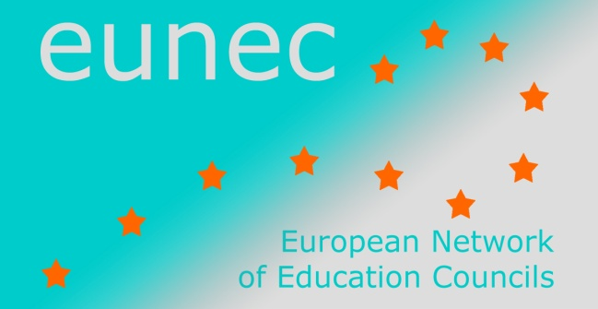
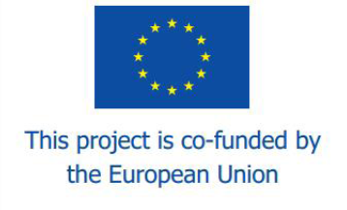

Seminar

‘Learning in the digital age’

Athens, 5-6 May 2014

Programme

Central questions

Do digital natives learn in a different way and what are the limitations of (informal) digital learning ?
Children and teenagers are flooded by information and communication technology. It has become an essential and common part of their daily life. They don’t question the pro’s and con’s; they don’t read the manuals; they use the technology. Social media are an extension of their social life and a platform to meet one another. It’s how they acknowledge each other. They are submerged with information. Information and communication technology offers a broad scope of sources for in-formal and non-formal learning. It is part of their life style and identity. They use ICT to meet, to play, to date, to connect, to explore the world and to construct (multiple) identities. We consider them as digital natives. It is a common understanding that these developments challenge the traditional content and nature of learning at school. ICT is considered to influence deeply the way how children learn. Learning gets a different meaning for youngsters who grew up with an amount of information within reach.
On the other hand it is obvious that an overflow of information does not necessarily result in a broad and critical understanding of the reality or in professional attitude. Yet learners working with digital media are tempted to focus more on concrete snapshots that can be of use (a form of “bricolage”) rather than to evaluate the reliability of information, to see broad connections and developments and to develop scientific or professional frameworks of reference. Another relevant distinction to make is the one between knowing what (cognition/facts) and knowing how (skills and attitudes). The enculturation and mastery of a scientific or professional practice (becoming a physician, a crafts man, a scientist) requires a socially constructed understanding that emerges from active collaboration, dialogue and interaction. Students need to absorb the social and practical aspects of a profession (its practices) and gain tremendously from their proximity to practitioners, especially when they can watch, listen, and participate. Enculturation and personal interaction is crucial to such learning, since relatively little of the complex web of practice is difficult to transfer.
Implications for the content and nature of learning
During the seminar EUNEC members will reflect on the consequences of these developments for schools.
- What is the meaning of these changing information and technology patterns for the learning and development of children (learning theory/learning psychology)? Is there a difference between young children, teenagers, learners in VET and students in higher education/adult education? To what extent does ICT change the “Bildungsconcept” of education? Is ICT questioning the humanistic content of ‘Bildung’? Is ICT part of a new concept of literacy such as the ability to communicate and express oneself with images, sound, and other media? Beyond this, information navigation is perhaps the key component of literacy in the digital age. Digital students have developed their own vernacular, a screen language for their digital culture.
- Does ICT change the nature of learning? Does the spread of digital learning implies a shift from an authority-based lecture model to discovery-based and constructivist learning model? Web based learning also “confuses” learning and entertainment, creating infotainment. What are the consequences of these developments for teachers’ roles changing from knowledge deliverers to developers of content and to co-constructors/coachers of the self-centred learning of pupils? What is the added value of open educational learning environments?

Stimulating an innovative approach of the use of ICT in education

During the seminar we will also address the critical conditions needed for mainstreaming of digital learning. We will discuss needs in the field of didactic and school infrastructure, development of content and how to finance these innovations.
Providing resources
ICT technology is of course more than the availability of hardware (which is increasing). It has also to do with connectivity, mobile devices, cloud applications, software and evidence based digital learning environments. The level and speed of connectivity are other preconditions for integrating ICT in education. Digital technologies evolve very fast and they require constant efforts to be update in order to respond to increasing demands.
ICT infrastructure and tools are unevenly available in different schools, regions and countries.
Providing such facilities requires huge investments from education and training institutions and public authorities. This “financial gap” strengthens existing inequalities and increases the gap between teaching practices and ICT in society. How to deal with scale effects needed to finance adequately up-to-date development of educational content and infrastructure, certainly in a policy climate of restricted budgets?
Even though the key for success depends foremost on an innovative climate in schools and on incentives from Member States, the EU also has also a role to play. What is the added value of a European digital agenda to this regard? The EU promotes best practices and supports exchanges across Member States. It can deliver benefits from cooperation and support the deployment and availability of digital technology and content through financial support and stimulate public-private partnerships at a European scale.
Digital contents
How and under which conditions there can the development of educational digital content be boosted? There are important disparities across languages, subjects and needs. There are also unclear legal framework conditions for producing, using, re-using and sharing educational contents (copyright, barriers to develop and implement innovative teaching and learning practices, re-use and sharing of contents).
Assessment and evaluation in open learning environments
As described before, the traditional curriculum based approaches of knowledge and skills acquired in a school context have shown to be too narrow. If the focus has changed from schooling to learning both in formal and non-formal context it is necessary to reconsider the techniques and the organization for assessment. Developing outcome based approaches and setting standards for validation of competences is needed.
Teachers' competences to develop innovative learning environments
Teachers are the main actors in turning on new technologies to rich and innovative learning environments. They have to rethink their evaluation and assessment practices to informal learning. They have to redefine their roles from deliverers of knowledge to co-creators and developers of competences. Teacher training and in-service professional development institutions often lack the vision and/or capacities to promote innovative teaching methods and an extensive and integrated use of technologies.

Sources to prepare the discussion

European Commission
Communication from the Commission ‘Opening up Education: Innovative teaching and learning for all through new Technologies and Open Educational Resources’
Staff working document: state of play in the EU, good practices, challenges, results of the consultation.
Survey of Schools: ICT in Education. Benchmarking access, use and attitudes to technology in Europe’s schools. A study prepared for the European Commission by European Schoolnet in collaboration with the university of Liège.

OECD
What are characteristics of new learning environments ?
The “Innovative learning environments” project is focused on innovative ways of organising the learning of young people. The project changes the spotlight of the well-known programme schooling for tomorrow from “schooling” to “learning”. Another change of paradigm is to start the analysis at the micro level (learning of the pupil) instead of at macro level (innovative policy). It consists of three strands : learning research, innovative cases and implementation and change.
http://oecdeducationtoday.blogspot.fr/2013/09/designing-21st-century-learning.html

Programme

Sunday 4 May 2014
Arrival of the participants and check in at the Royal Olympic Athens Hotel (www.royalolympic.com)
17.00 – 19.00 h Executive committee meeting at the hotel (only for executive committee members)
19.00 – 20.00 h General assembly meeting at the hotel (only for general assembly members)
20.00 h Welcome dinner for all the participants in the Plaka area

Monday 5 May 2014
09.30 – 10.00 h Welcome by Adrie van der Rest, EUNEC president, by Professor Sokratis Katsikas, President of the Greek National Council of Education, and by Professor Athanasios Kyriazis, General Secretary of the Greek Ministry of Education and Religious Affairs
10.00 – 11.15 h Innovative Learning Environments, by Marco Kools, OECD Analyst, Innovation and Measuring Progress Division, Directorate for Education and Skills
Questions and answers
11.15 – 11.45 h Coffee break
11.45 – 12.45 h Digital Systems for Opening Up Education, by Professor Demetrios G. Sampson, Department of Digital Systems, University of Piraeus, Greece
Questions and answers
12.45 – 14.00 h Lunch
14.00 – 14.45 h European Commission Communication ‘Opening Up Education’, videoconference with the participation of Ricardo Ferreira and Konstantin Scheller, European Commission, DG Education and Culture
Questions and answers
14.45 – 15.30 h Presentation of the report ‘Mapping and Analysing Prospective Technologies for Learning. Results from a consultation with European stakeholders and roadmaps for policy action’, by Spiros Borotis, MENON network (http://ftp.jrc.es/EURdoc/JRC88469.pdf)
15.30 – 16.00 h Coffee break
16.00 – 17.30 h Interactive debate leading to conclusions
Free evening

Tuesday 6 May 2014
09.00 – 11.30 h School visit at the 1st Experimental Junior High School of Athens (http://1gym-peir-athin.att.sch.gr)
12.00 – 14.00 h Cultural programme: visit of the Acropolis Museum
14.00 h Closing lunch

