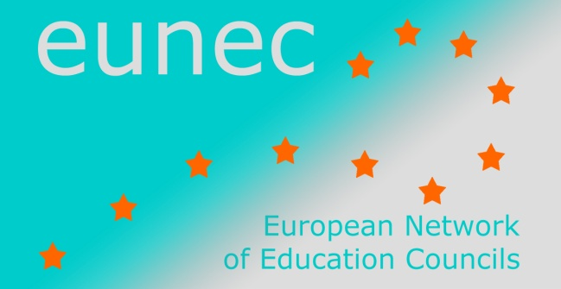

Seminar on ‘Community schools’

Brussels, 23-24 May 2013.

PROGRAMME

Central question

The concept
The central theme for this seminar will be the embeddedness of schools in the local society and communities. In some countries networking activities of schools are described as “community schools”, “broad schools” (brede scholen).
A community school invests in networking and cooperation with relevant partners in and outside the school in order to broaden the scope of learning, to enlarge the educational time and raise the quality of the educational offer, in order to improve performances of all pupils.
In the definition we can distinguish two main features: networking and raising the quality of learning.
Quality of learning
The community school is an active partner in a broad range of community building activities, but the scope is always improving the learning and competences of youngsters. Both “traditional” learning outcomes such as languages, mathematics, history, geography, learning to learn, interaction, and transversal skills, soft skills and the whole personality of the pupils are at stake. In that sense a community school is more than a multifunctional school building being used by different actors and for different purposes (effectiveness).
A community school is not a unique model set forward for all schools and all networks. Because every local community is different, because the learning needs of pupils differ, because local sensibilities and partners are different, every school needs to set forward objectives based on an analysis of the local situation, the profile of pupils and parents and the strength of local networks. Enhancing the quality of learning has different features and characteristics depending from school to school.
Networking
A community school is based on partnerships between the school, the family and the neighbourhood and other sectors involved such as the cultural sector, welfare, neighbourhood development and sport, with the objective to offer maximal development opportunities for all children and youngsters. This works in two directions: schools offer services to the environment, or, the other way around, schools benefit from opportunities offered by the environment.
Community schools seek to enhance their involvement and networking with the social environment of youngsters (informal learning platforms, youth work), with the parents organisations, with the welfare services, with the social and economic partners. Depending on the main objectives the school sets forward, the characteristics and the partners involved in the network will change. The setting of a multicultural big city is different from the one at the country side.
Depending of the context the focus can be on collaboration
- with organisations and services concerned with health and wellbeing of children,
- with formal and informal learning environments stimulating different talents of youngsters (general development, cognitive activity, creative activity, technical activity, sports activity, language activity,… )
- with parents groups, social and welfare organizations and services integrating children coming from vulnerable social environments (equal opportunities),
- with social and economic partners in order to enhance the sustainable integration of youngsters in labor market and social life ….

Links with former EUNEC seminars and conferences
In that sense it is a concept linking excellence in education with many other pedagogic and social challenges such as equal opportunities, social cohesion, informal learning opportunities, parental involvement in schools. The debate has also many links with the debate on the policy making capacity of local schools.
In Budapest, in 2011, EUNEC has discussed the theme of ‘Bildung in a lifelong learning perspective’, exploring the broad aim of education to contribute to the development of the whole human being. In Amsterdam, in 2012, EUNEC has discussed the theme of ‘Excellence in education’ and insisted on the objective of education to enhance the conditions to raise quality of learning for every pupil.
The attention that EUNEC will be paying to ‘community schools’ during this seminar, is related to both discussions.

Questions to the EUNEC member councils

Improving the relationship between school – local community and networking platforms
Is this theme part of the policy debate in your country? Is the definition set forward by EUNEC relevant? Are essential elements missing? Do you recognise the differentiation between community schools and multifunctional schools? What is the perspective from which the issue is raised?
- debate on equal opportunities,
- raising levels and standards of learning
- integration formal and informal learning
- multi functionality of school buildings
- other
How does your council consider the debate on the embeddedness and the partnership of schools with the local community? Do you have any relevant recommendations on this theme?

The concept of community schools.
School level: Is the concept of “community schools” known in your country? Or is it used with another name? Are there schools in your country working with this concept? What priorities have they chosen? What are their experiences of difficulties?
Central policy making level: Is the concept integrated at a central policy level? What is the role of the central government, of the community and of the school?

Programme

Wednesday 22 May 2013

Arrival of the participants and check in at the hotel (www.hotelbloom.be).
17.00 – 20.00 Executive committee meeting at the Vlor, Kunstlaan 6, 1210 Brussels and executive committee dinner (only for executive committee members)

Thursday 23 May 2013
Chair of the day Adrie van der Rest, EUNEC president
9.00 – 9.15 h Welcome by Adrie van der Rest, EUNEC president, and by Mia Douterlungne, secretary general of the Flemish Education Council and of EUNEC
9.15 – 10.15 h Key note by professor Alan Dyson, Centre for Equity in Education, University of Manchester
10.15 – 10.45 h Questions and debate
10.45 – 11.15 h Coffee break
11.15 – 12.15 h Presentation of good policy practice: the Netherlands. ‘Collaboration, a matter of search, utilize and intensify?’ Job Van Velsen, project leader of the ‘Landelijk Steunpunt Brede Scholen’.
12.30 – 13.00 h General Assembly meeting (only for general assembly members)

13.00 – 14.00 h Lunch at the Vlor

14.00 – 15.00 h Presentation of good policy practice: The Community Focused Schools initiative in Wales. Sue Rivers, Deputy Chairperson of GTCW, General Teaching Council Wales.
15.00 – 16.00 h Presentation of good policy practice: Community Schools Policy Initiatives in Romania. Magdalena Balica, senior researcher at the Institute of Educational Sciences, Bucharest.
16.00 – 16.15 h Coffee break
16.15 – 17.00 h Conclusions and lessons learnt
18.15 – 22.00 h Guided walk and dinner in Brussels city centre (restaurant ‘Les Brigittines’)

Friday 24 May 2013 The link with the workfloor: school visit.
Chair of the day Mia Douterlungne, EUNEC secretary general
09.00 – 10.00 h Community Schools in Brussels
The Brussels context. Piet Vervaecke, director ‘Onderwijscentrum Brussel’
Community Schools in Brussels. Vision and objectives. An Claeys, community schools coordinator.
Community School in Brussels. Framework and implementation. Piet Vervaecke, director ‘Onderwijscentrum Brussel’

10.30 – 12.30 h School visit at Sint-Joost-aan-Zee, Brussels.
Presentation of the school. Svens Moens, director.
Exchange with director, community schools coordinator, partner, parent, teacher.
Guided visit of the school. Sven Moens, director.

13.00 h Lunch at Madou’s Provence

EUNEC statements on ‘Bildung in a lifelong learning perspective’, Budapest, 2011
EUNEC statements on ‘Excellence in education’, Amsterdam, 2012

