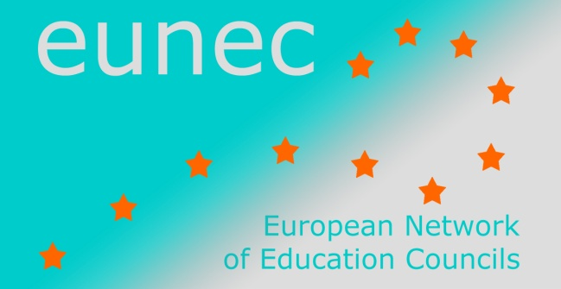
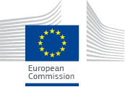

Seminar on ‘Community schools’

Brussels, 23-24 May 2013

INPUT FROM EUNEC MEMBERS

Dutch Education Council
There was a policy debate over this theme in the beginning of the millennium. There was a need for schools that encompassed more than school education only. As a results, schools invested in the development of broad schools (‘brede scholen’). Broad schools are more or less the type of school that the EUNEC described. The term broad schools refers to schools that combine education with child care, health care, welfare, sport and/or culture. The societal function of the broad school should be explicit.
The goals of the broad schools are mainly to enhance learning outcomes and broad talent development, in particular for disadvantaged pupils. There is a tendency to focus more on talent development of the child and less on the involvement with parents and neighbours.

Recommendations of the Dutch Education Council
Although there are many schools that form ties with partners in the community, this largely depends on initiative of the local partners. It is not a structural policy in the Dutch schools. The Dutch Education Council has therefore advised in 2010 that every school should develop a societal programme: a plan how school and community can strengthen their ties, in particular with the societal elite. People who have successful careers in industry, society, art, music or who are in other ways successful are encouraged to connect with the school.
In another policy paper about Extended Education (“Uitgebreid onderwijs”, 2010, see abstract on internet) the Dutch Education Council recommended that schools should extend their formal and informal learning opportunities.
In the Education Council's view, extended education means that the school (or other education-oriented party) offers something extra which is aimed at 1) meeting the legal requirements (f.e. basic reading and math skills), 2) the broader and deeper development of talent, and 3) broadening the views of pupils or students towards work and society. Examples are schools with an extended school day, schools with special cultural or sport activities, schools with English or Spanish classes. The three goals also reflect the three types of extended education that we can distinguish: extended education aimed at improving learning performance, extended education aimed at enrichment, and extended education aimed at providing an orientation towards work and society. This last goal is more important for disadvantaged pupils.
This plead is repeated in an advice about cultural education (‘cultuureducatie: leren, creëren, inspireren!’, 2012). Schools should more often use the possibilities cultural institutions can offer.
Another relevant publication is the advice about the partnership between parents and education (Ouders als partners, 2010).
There are many broad schools in primary education (ca 2000 or 29% in 2011) and in secondary education (ca 400 or 33% in 2011). In all municipalities there is at least one broad school. The growth is decelerating.
There is no national policy that describes how these broad schools must be organised. This results in a wide variety of schools. Some schools are located in a multifunction building that includes child care organisations and schools, sometimes combined with other welfare organisations. In other cases, organisations cooperate without from stand-alone-buildings. This type of broad school has grown in popularity in recent years, especially in the countryside, whereas the multifunctional building has become less common (from 50% to 33% in recent years). In some cases, education and child care are integrated in one organisation for children 0-12 years old with one board of directors. These organisations are called integrated child centers. The expectation is that their numbers will increase.
The municipalities have a large part in these broad schools (coordinating, housing, preschool education, subsidized provisions), although schools are taking over their role.
Because of the variety in broad schools, there effectiveness is difficult to measure. Other difficulties are the substantive coordination of educational and other programms, and the differences in funding and legal rights and obligations. For example, education and child care are funded by different Ministries.

www.rijksoverheid.nl
See the yearly report of Oberon, 2011. http://www.oberon.eu/Beheer/DynamicMedia/publicaties/BS-jaarbericht2011.pdf
Abstract: http://www.onderwijsraad.nl/upload/english/publications/extended-education.pdf
Abstract: http://www.onderwijsraad.nl/upload/english/publications/cultural-education.pdf
Abstract: http://www.onderwijsraad.nl/upload/english/publications/parents-as-partners.pdf

